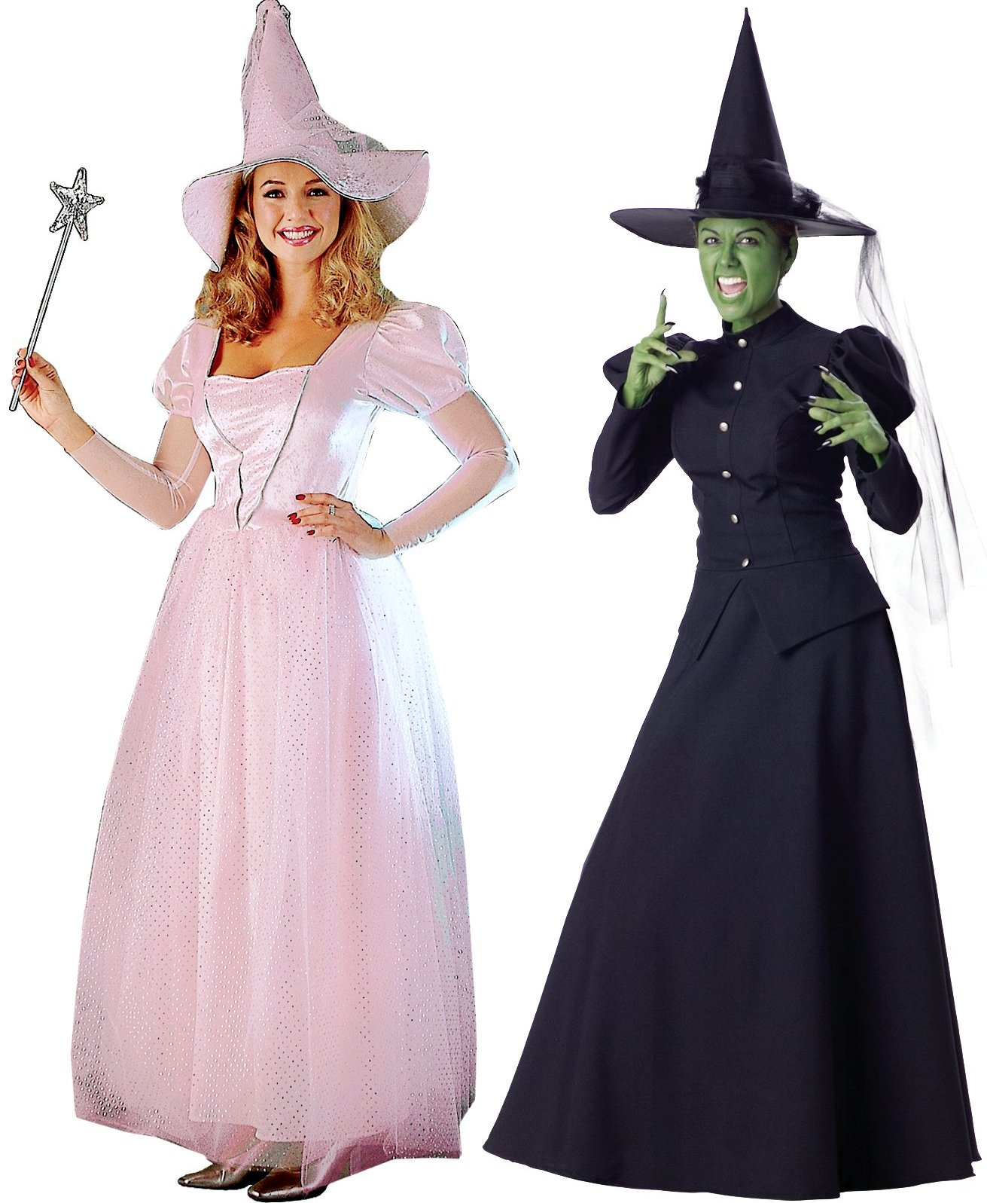

GOOD WITCH, BAD WITCH
There was a thunder storm that night and a terrible wind. Outside it sounded like a team of wolves and a team of ghosts were having a ‘being noisy’ competition. Every now and then, a giant clapped his approval after a particularly good effort by one of the teams.

Erin tossed and turned in her bed. She could not get to sleep. Lightning flashed and cast momentary shadows of dancing monsters on the bedroom walls. Erin was scared. She needed to hide. She needed to get away from the wolves, away from the ghosts, away from the giant and away from the monsters. She got out of bed. Lottie was fast asleep beside her, dreaming pleasant dreams, blissfully unaware of the noisy competition. Erin went out onto the landing. She heard footsteps coming up the stairs and froze with fear. The footsteps got closer but Erin couldn’t move. Then around the corner came a figure a little taller than her. Louis stopped in his tracks, startled to see someone standing there. Then they both recognised one another and began to laugh.

“I can’t sleep,” said Erin.

“Me neither,” Louis replied. “I hate thunder storms. Let’s hide somewhere. I’ve brought my torch. What about in here? The monsters will never find us in here.” Louis pointed to the little door at the top of the stairs. Erin nodded. Louis opened the door and they stooped a little to go inside. Then they both stood with mouths agape as they suddenly found themselves somewhere quite unexpected.

In front of them was a long wooden path. The wood of the path was dark and shiny and smooth at the sides, but down the middle it was rough and worn, as if many feet had passed this way before. Either side of the path was a high fence. It was too high to see over and there were no gaps to look through. Louis tried to reach up to the top of the fence. He could not. He tried jumping. Still he didn’t come close. Then he tried lifting Erin up to see if she could reach. But it was no use. Louis reached into his pocket and found a coin. He took it out, threw it over the top of the fence and waited to hear what sound it would make on the other side. He waited some more. He looked at Erin. They both waited some more. No sound ever came.

On walked the intrepid adventurers, feeling more than a little uneasy about the coin experiment, but determined to see what lay ahead. Eventually, the path led to a tall arch. After walking through the arch they found themselves in a small room. A thick red carpet covered the floor. It also covered the ceiling and the walls.

“How strange,” Erin thought. “A carpet on the ceiling. What ever can that be for? Nobody ever walks on the ceiling. Well, spiders do of course, and flies and daddy long legs. Maybe the carpet is for them.”

In the middle of the far wall was a picture frame. There wasn’t a picture in the frame. It just had a large red letter A in the middle on a plain white background. In the centre of the room was a small black table and on the table stood a white box with a single red button in the centre of it.

Before Erin had time to think about it, Louis strode confidently forward and pressed the button. Suddenly the letter in the picture frame changed quickly to a B and then a C and then a D. It kept changing again and again, going through all the letters in the alphabet. After Z it changed back to A again and then B again and then C again. This continued until all the letters in the alphabet had appeared three times. Then the changes became slower. Each letter stayed just a little longer. Eventually the letter stopped changing. It stopped at the letter W. A faint cracking noise could be heard and the outline of a door began to appear around the picture frame.

Erin and Louis looked at each other, their eyes wide, and then looked back at the newly appeared door. They looked at each other again. Without speaking, they both began to move towards the door. The new door had no handle. Louis pushed on the right side of the door. It seemed stuck. Erin pushed on the left side. This time, the door swung open and they walked through into what appeared to be a shop. There were a counter and various shelves with bottles and bags of what looked like crushed up dried leaves on them. Behind the counter, a woman stood over a stove on which stood a large black cooking pot with steam rising from it. The woman wore a blue dress and an apron with red and white checks. Her hair was fiery red and was tied neatly in bunches. Her eyes were deepest blue with delicate wrinkles either side and her skin was pale with brown freckles.

“Hello there, my dears,” said the old lady. “What can I do for you?”

“Who are you?” asked Louis.

“My name’s Claria. I’m a witch. What brings you here? I don’t think I’ve seen you two before.”

“Are you a good witch or a bad witch?” asked Louis.

“I’m not sure I know what you mean,” replied the witch.

“You know! Are you wicked or are you kind?” Louis explained further.

“Hmmm,” pondered the old lady, rubbing her chin for an extra boost of thinking power. “Do I have to choose one or the other?”

“Yes, of course! Everyone knows that all witches are either good witches or bad witches. You can generally tell by looking at them. You know: the bad ones are green with warts and great big hooked noses. They talk in croaky voices and cackle instead of laughing. What’s more, the things they laugh about are usually not funny at all, but really horrid,” explained Erin.

“That’s right!” Louis agreed. “And good witches are beautiful with pretty pink dresses and wands with stars on and silver crowns and they use big bubbles to fly around in instead of broomsticks and their voices are like a carol-singing choir, only with the volume turned down a bit.” Louis often saw little point in separate sentences.

“I see,” said the witch. She rubbed her chin some more, calling on her last reserves of thinking power by vigorously going over a bit she had missed the first time. But still the answer did not come to her. “Do you know,” she said eventually, “I really don’t know. Nobody ever asked me before and as you can see, I don’t really fit either of your descriptions. Do you think someone should have told me what sort of witch I am? Maybe my mum should have told me when I was little, or do I just have to decide for myself?”

The two children looked at each other for a moment, each one hoping that the other might know the answer. After a little while, Louis thought of another question: “What kind of witch was your mum?”

“My mum?” the witch pondered. “My mum wasn’t a witch at all. She was a goat herd.”

“What’s a goat herd?” asked Louis.

“Like a shepherd, only you look after goats instead of sheep,” the witch explained.

“Oh, right!” Louis exclaimed. “So someone who looks after cows must be a coward!”

“Why are you a witch then?” asked Erin, returning everyone to the question.

“Why? I don’t know really. I suppose I was just very good at spelling when I was at school,” the witch answered, sounding none too sure of herself.

“I know!” Erin suddenly had a flash of inspiration. “Do you do nice spells or do you do nasty spells?”

“Yeh! Nice or nasty?” reiterated Louis, pressing the point.

“I’ve never really thought about it,” the witch had to admit. “How do you tell?”

“That’s easy,” Louis chipped in. “When you do nice spells, you will feel nice inside. In here,” he pointed to his chest. “You’ll feel all tingly and warm. Also, some people might smile at you and say ‘thank you’ to you in a soft voice. They might do something nice for you in return. When you do nasty spells, you will feel a bit sick. A bit further down,” he pointed to his belly. “People will shout at you and tell you off. They might stop speaking for a while or they might even never speak to you again. They might do something nasty to get back at you.”

“I see,” said the witch. “Well, now you’ve explained it, I think I probably do both kinds of spell.”

“Both!?” exclaimed the children in unison.

“You can’t do both! You have to choose one or the other. Otherwise, how will anyone know what kind of witch you are?” Erin continued the questioning.

“I’ve never really thought about it like that,” the witch had to admit. “I didn’t know that people needed to know what kind of witch I am.”

“Oh, yes.” Louis confirmed. “People need to know what kind of witch you are. If they want a nice spell casting, then they go and see a good witch. If they want a nasty spell, then they go to see a wicked witch. I think you’d better decide what kind of witch you are right away.”

“Hmmm,” the witch pondered some more. This time she scratched her head as she had lost all faith in her chin. “How can I decide?”

“Well, which kind of spells do you like best?” Erin asked.

“That depends, really,” the witch answered. “Sometimes I am tired and fed up. Sometimes people are horrid to me or to my friends. Then I think I like the nasty spells best. I can get my own back on them and teach them a lesson. But at other times, people are really nice to me. When the nice people need my help, or I want to thank them, then I feel much more like doing the nice spells.”

“But you must like one better than the other,” Erin continued. “What about that feeling you get? Do you prefer the one in your chest or the one in your belly? Do you like people to smile and say thank you or do you prefer them to shout and get cross?”

“Oh, that’s easy!” The witch decided. “The first ones for definite! No contest.”

“That’s settled then,” said Louis. “You should definitely be a good witch. It’s good spells for you.”

“But what about when people are horrible to me?” The witch asked. “Can’t I just do a few little nasty spells to get back at them?”

“Oh, no, no!” Erin answered. “Good witches must never cast nasty spells. If you want to be a good witch, you must only do nice spells. That’s the rules.”

“Not even a teeny tiny nasty spell?” the witch asked. “I don’t want to turn anyone into a toad or anything. I was thinking more along the lines of a bit of an earache, or maybe a verruca.”

“Nope. Absolutely forbidden I’m afraid. I’m something of an expert on these things. I’ve watched the Wizard of Oz nine times, don’t you know?” said Erin.

“But what am I supposed to do when people are nasty to me?”

“Well,” said Erin. “I’m not sure about that one. I don’t think that was in the Wizard of Oz. Maybe you could try doing a nice spell for them anyway. Perhaps they are just feeling a bit tired and fed up and you could do a ‘wide awake not fed up’ spell. Or maybe someone else was nasty to them and you can do a ‘forget about the nastiness’ spell. Or maybe you could just ignore them and do a nice spell for someone else who you think deserves it.”

“I like the idea of that!” said the witch. “Thank you children. Can I do a spell for you now?”

“We can’t sleep,” said Louis. “There’s a thunderstorm. Can you make it go away?”

“I have just the thing,” said the witch. She reached up to a high shelf and took down a dusty green bottle. She dusted it down and pulled out the cork. “Take some of this, each of you. Half for you and half for you.” she said.

Louis and Erin both took a drink from the potion and the room around them began to fade.

The next morning, Erin was awoken by her little sister. She was back in her bed, and the thunder storm had stopped.

“What a strange dream I had!” Erin thought to herself. “Wait until I tell Louis about it.” She got up to go to the toilet and noticed the little door at the top of the stairs was ajar. Slowly she opened it further an inch at a time. Behind the door there was just a cupboard full of boxes. Erin laughed to herself. Of course. It was just a dream. Then out of the corner of her eye she noticed something familiar on the floor. It was a green bottle with dust clinging to it in places. Its cork lay next to it. Erin picked up the bottle and looked inside. It was empty. She thought she faintly heard a coin landing somewhere and spinning to a rest on the ground.

THE END

